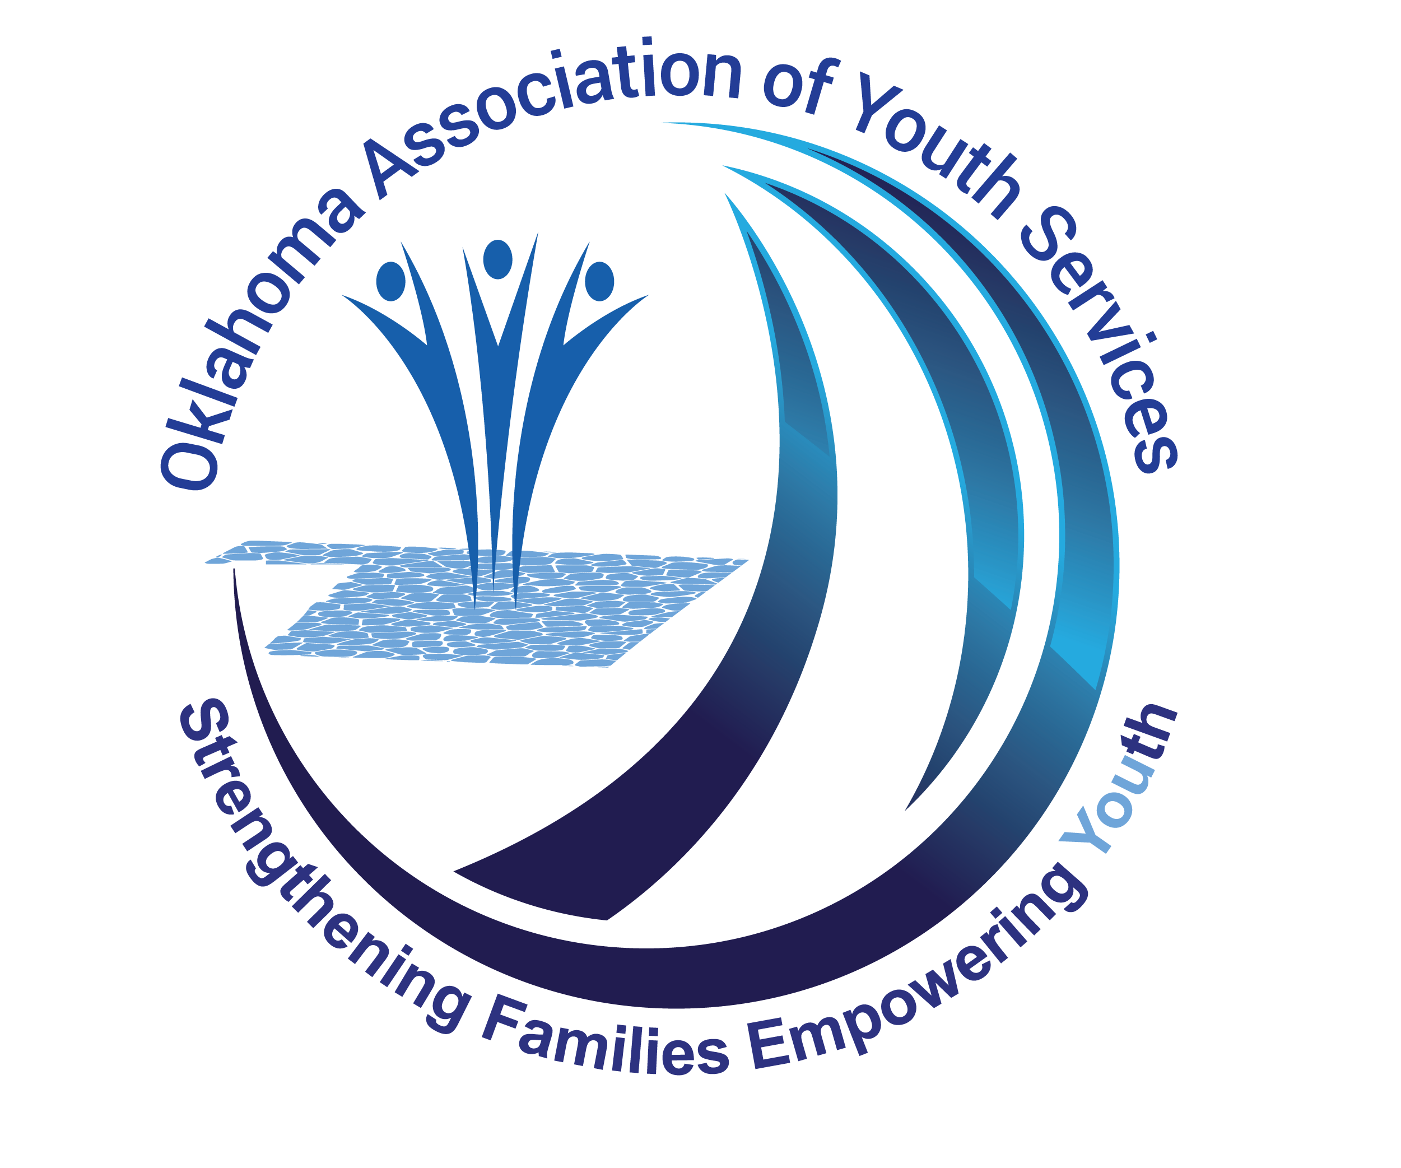
Oklahoma Association of Youth Services
LEARNING OPPORTUNITY EVALUATION

Using the below scale please rate the workshop components by circling the corresponding response that most closely articulates your thoughts.
Name of Training: _______________________________________________________________
Your Name: ______________________________________ Date: ______________________

License Number (If Applicable) ________________________

- Workshop contained relevant information for my profession

- Strongly Disagree B. Disagree C. Neither agree nor disagree D. Agree E. Strongly Agree

- Workshop gave practical ways to use the information conveyed

- Strongly Disagree B. Disagree C. Neither agree nor disagree D. Agree E. Strongly Agree

- Workshop facilitator was knowledgeable, spoke clearly, enunciated well and was audible

- Strongly Disagree B. Disagree C. Neither agree nor disagree D. Agree E. Strongly Agree

- Venue was comfortable and designed for maximum learning

- Strongly Disagree B. Disagree C. Neither agree nor disagree D. Agree E. Strongly Agree

- Handouts and presentation method provided clarification of workshop materials

- Strongly Disagree B. Disagree C. Neither agree nor disagree D. Agree E. Strongly Agree

- The Course learning objectives were clear and were clearly referenced and sequenced throughout the learning opportunity.

- Strongly Disagree B. Disagree C. Neither agree nor disagree D. Agree E. Strongly Agree

Please list future learning opportunities that you would like to see the Oklahoma Association of Youth Services Offer: __________________________________________________________________________________________________________________________________________________________________________
Please provide any additional comments to help us provide the best learning opportunities possible:

__________________________________________________________________________________________________________________________________________________________________________

